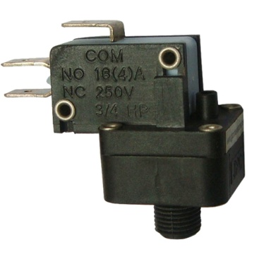

**Type ZP**

**Snap action contact air switch, high electrical rating**

Uses: High electrical rating, for 250V.

Main applications: Direct actuating of pumps and blowers in spas and swimming pools, sink erasers, professional or home appliances used with risks of water splashing.

Membranes: EPDM, dia 22 mm.

Fluid: air.

Fitting: Plastic spout for 1/8(3mm) or 1/16(1.5mm) ID flexible plastic tubing maximum hardness 70 shore A.

Pressure: positive.

Housing: PA66, UL94 VO and ABS.

Contact: SPNO or SPDT, snap action.

Maximum pressure: 4 bars (58 PSI).